chapter10 : Data Transformation

library(ggplot2)  
library(gridExtra)  
library(dplyr)

##   
## Attaching package: 'dplyr'

## The following object is masked from 'package:gridExtra':  
##   
## combine

## The following objects are masked from 'package:stats':  
##   
## filter, lag

## The following objects are masked from 'package:base':  
##   
## intersect, setdiff, setequal, union

## 10.1 Introduction

## 10.2 Filter observations

ggplot(diamonds, aes(x, y)) +  
 geom_bin2d()

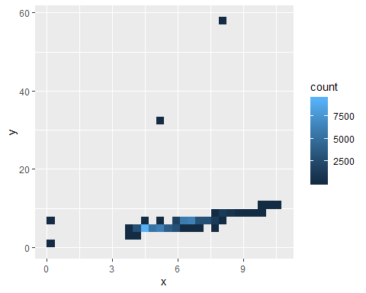

filter(diamonds, x==0 | y == 0)

## # A tibble: 8 x 10  
## carat cut color clarity depth table price x y z  
## <dbl> <ord> <ord> <ord> <dbl> <dbl> <int> <dbl> <dbl> <dbl>  
## 1 1.07 Ideal F SI2 61.6 56 4954 0 6.62 0  
## 2 1 Very Good H VS2 63.3 53 5139 0 0 0  
## 3 1.14 Fair G VS1 57.5 67 6381 0 0 0  
## 4 1.56 Ideal G VS2 62.2 54 12800 0 0 0  
## 5 1.2 Premium D VVS1 62.1 59 15686 0 0 0  
## 6 2.25 Premium H SI2 62.8 59 18034 0 0 0  
## 7 0.71 Good F SI2 64.1 60 2130 0 0 0  
## 8 0.71 Good F SI2 64.1 60 2130 0 0 0

diamonds_ok <- filter(diamonds, x > 0, y > 0, y < 20)  
ggplot(diamonds_ok, aes(x, y)) +  
 geom_bin2d() +  
 geom_abline(slope = 1, colour = "white", size = 1, alpha = 0.5)

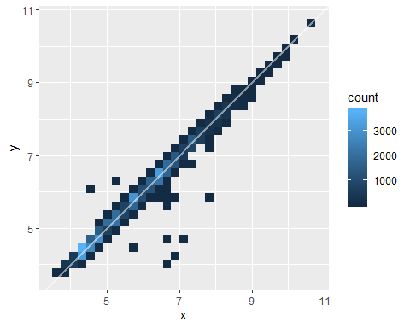

### 10.2.1 Useful Tools

- first argument to *filter()* is a data frame.

- second and subsequent arguments must be logical vectors.

*: filter()* selects every row where all the logical expressions are *TRUE* !!

### 10.2.2 Missing Values

- in *filter()*, *NA* values are automatically dropped.

x <- c(1, NA, 2)  
is.na(x)

## [1] FALSE TRUE FALSE

## 10.3 Create New Variables

diamonds_ok2 <- mutate(diamonds_ok,  
 sym = x - y,  
 size = sqrt(x ^ 2 + y ^ 2)  
)  
diamonds_ok2

## # A tibble: 53,930 x 12  
## carat cut color clarity depth table price x y z sym size  
## <dbl> <ord> <ord> <ord> <dbl> <dbl> <int> <dbl> <dbl> <dbl> <dbl> <dbl>  
## 1 0.23 Ideal E SI2 61.5 55 326 3.95 3.98 2.43 -0.0300 5.61  
## 2 0.21 Premi… E SI1 59.8 61 326 3.89 3.84 2.31 0.05 5.47  
## 3 0.23 Good E VS1 56.9 65 327 4.05 4.07 2.31 -0.02 5.74  
## 4 0.290 Premi… I VS2 62.4 58 334 4.2 4.23 2.63 -0.03 5.96  
## 5 0.31 Good J SI2 63.3 58 335 4.34 4.35 2.75 -0.01000 6.14  
## 6 0.24 Very … J VVS2 62.8 57 336 3.94 3.96 2.48 -0.02 5.59  
## 7 0.24 Very … I VVS1 62.3 57 336 3.95 3.98 2.47 -0.0300 5.61  
## 8 0.26 Very … H SI1 61.9 55 337 4.07 4.11 2.53 -0.04 5.78  
## 9 0.22 Fair E VS2 65.1 61 337 3.87 3.78 2.49 0.09 5.41  
## 10 0.23 Very … H VS1 59.4 61 338 4 4.05 2.39 -0.0500 5.69  
## # … with 53,920 more rows

ggplot(diamonds_ok2, aes(size, sym)) +  
 stat_bin2d()

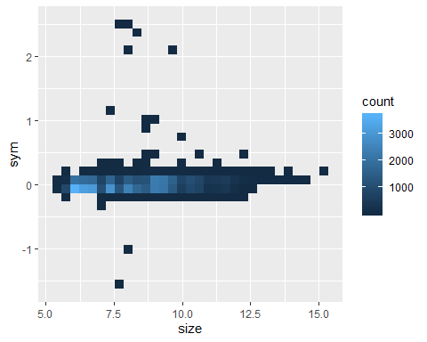

g1 = ggplot(diamonds_ok2, aes(abs(sym))) +  
 geom_histogram(binwidth = 0.10)  
diamonds_ok3 <- filter(diamonds_ok2, abs(sym) < 0.20)  
g2 = ggplot(diamonds_ok3, aes(abs(sym))) +  
 geom_histogram(binwidth = 0.01)  
grid.arrange(g1,g2,ncol=2)

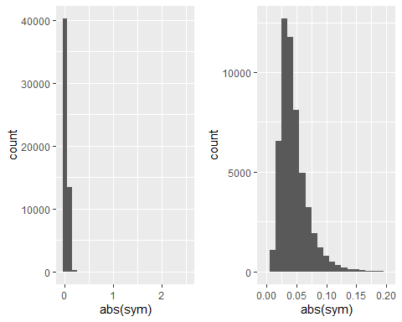

## 10.4 Group-wise Summaries

dplyr does summaries in two steps: 1. Define the grouping variables with *group by()* 2. Describe how to summarise each group with a single row with *summarise()*

by_clarity <- group_by(diamonds, clarity)  
sum_clarity <- summarise(by_clarity, price = mean(price))  
head(sum_clarity)

## # A tibble: 6 x 2  
## clarity price  
## <ord> <dbl>  
## 1 I1 3924.  
## 2 SI2 5063.  
## 3 SI1 3996.  
## 4 VS2 3925.  
## 5 VS1 3839.  
## 6 VVS2 3284.

ggplot(sum_clarity, aes(clarity, price)) +  
 geom_line(aes(group = 1), colour = "grey80") +  
 geom_point(size = 2)

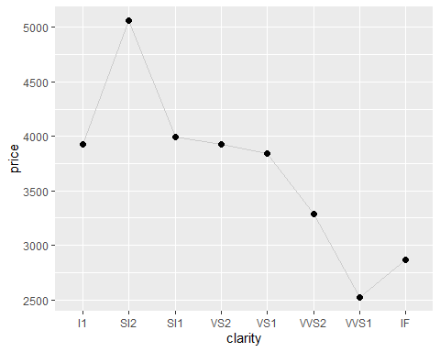

cut_depth <- summarise(group_by(diamonds, cut, depth), n = n())  
cut_depth <- filter(cut_depth, depth > 55, depth < 70)  
head(cut_depth)

## # A tibble: 6 x 3  
## # Groups: cut [1]  
## cut depth n  
## <ord> <dbl> <int>  
## 1 Fair 55.1 3  
## 2 Fair 55.2 6  
## 3 Fair 55.3 5  
## 4 Fair 55.4 2  
## 5 Fair 55.5 3  
## 6 Fair 55.6 4

ggplot(cut_depth, aes(depth, n, colour = cut)) +  
 geom_line()

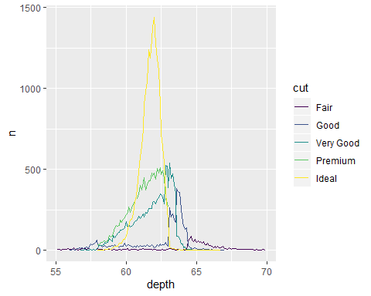

### 10.4.1 Useful Tools

*summarise()* needs to be used with functions that take a vector of n values and always return a single value - Counts: n(), n distinct(x) - Middle: mean(x), median(x) - Spread: sd(x), mad(x), IQR(x) - Extremes: quartile(x), min(x), max(x) - Positions: first(x), last(x), nth(x, 2)

### 10.4.2 Statistical Considerations

The following example extends our previous summary of the average price by clarity to also include the number of observations in each group, and the upper and lower quartiles. It suggests the mean might be a bad summary for this data - the distributions of price are so highly skewed that the mean is higher than the upper quartile for some of the groups!

by_clarity = diamonds %>%  
 group_by(clarity) %>%  
 summarise(  
 n = n(),  
 mean = mean(price),  
 lq = quantile(price, 0.25),  
 uq = quantile(price, 0.75)  
 )  
by_clarity

## # A tibble: 8 x 5  
## clarity n mean lq uq  
## <ord> <int> <dbl> <dbl> <dbl>  
## 1 I1 741 3924. 2080 5161   
## 2 SI2 9194 5063. 2264 5777.  
## 3 SI1 13065 3996. 1089 5250   
## 4 VS2 12258 3925. 900 6024.  
## 5 VS1 8171 3839. 876 6023   
## 6 VVS2 5066 3284. 794. 3638.  
## 7 VVS1 3655 2523. 816 2379   
## 8 IF 1790 2865. 895 2388.

ggplot(by_clarity, aes(clarity, mean)) +  
 geom_linerange(aes(ymin = lq, ymax = uq)) +  
 geom_line(aes(group = 1), colour = "grey50") +  
 geom_point(aes(size = n))

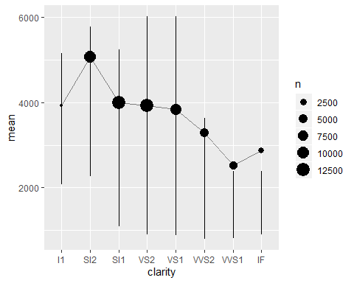

## 10.5 Transformation Pipelines

cut_depth <- group_by(diamonds, cut, depth)  
cut_depth <- summarise(cut_depth, n = n())  
cut_depth <- filter(cut_depth, depth > 55, depth < 70)  
cut_depth <- mutate(cut_depth, prop = n / sum(n))

Alternative approach with the **pipe** %>% !!

cut_depth <- diamonds %>%  
 group_by(cut, depth) %>%  
 summarise(n = n()) %>%  
 filter(depth > 55, depth < 70) %>%  
 mutate(prop = n / sum(n))